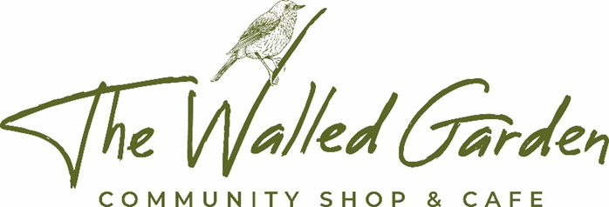

Plumstead Community Shop Limited

BUSINESS PLAN

01 March 2019

The Community Shares Standard mark is awarded by the Community Shares Unit to offers that meet national standards of good practice. For more information about community shares, the Community Shares Standard mark and the Community Shares Unit go to: communityshares.org.uk



Contents

Executive Summary 3
1. Background and Current Situation 6
2. Vision 7
3. Social Returns 8
4. Legal Structure 9
5. Management Structure 9
6. Market Research 10
7. The Business 13
8. The Share Offer 16
9. Resource Implications 17
10. Timescale 17
11. Risks 18
12. Communication 20
Appendix 1 – The MC 21
Appendix 2 - Five Year Forecast 23
Appendix 3 – Balance Sheet ..25
Appendix 4 – Income and expenditure .26
Appendix 5 – Café projections 27
Appendix 6 - Cashflow 28
Appendix 7 – Year 1 projections by month 29
Appendix 8 - Depreciation 30

Executive Summary

- Background and Current Situation

A growing population without a local shop creates an opportunity to establish a community owned shop and café. The former hospital site, with 300 new homes being built and a derelict walled garden in community ownership is an ideal site.
Our project came about when a visitor to the Broadland Clinic, saw how this link could be restored, whilst at the same time creating a community wide project of a community owned shop and cafe benefiting both local residents and service users at the clinic. The clinic has funded an advisor to our project, recognising how work experience in our community shop, café & garden will build confidence and new skills in service users preparing to return to society.

The Plunkett Foundation, who have supported more than 300 successful community owned shops have been advising us since day one. A community survey confirmed strong support from residents, parents with children at the adjacent school and those working at nearby businesses. Our successful application to have a local Post Office will be a major benefit for the success of the business.

- Vision

To create a shop and cafe owned and run by the community, in order to provide a hub to bring together and foster community spirit in the Plumstead villages, while providing a link to the history of the site through the walled garden.

- Social Returns

A facility where the whole community can come together creating an opportunity for social adhesion and reduced social isolation. A place to shop, meet, eat and drink, where everyone is welcome and feels part of what is going on.

Our shop, café and garden will provide employment experience for vulnerable adults based at the nearby Broadland Clinic.

It has been proven elsewhere that a community owned shop and café rapidly becomes a social hub, providing volunteering opportunities and alleviating social isolation.

- Legal Structure

Plumstead Community Shop Ltd (the Society) has been registered with the Financial Conduct Authority (FCA) as a Community Benefit Society (CBS), which is a legal and corporate body where any profits are used for the benefit of the wider community.

- Management Structure

Plumstead Community Shop Ltd is managed by the Management Committee (MC) according to FCA approved model rules. The responsibility of the MC is to engage in the Society's governance in the delivery of the project. The MC will step down at the first AGM and a new MC will be elected by the membership. Once trading, the shop and café will have a manager and assistant manager to run the day to day business and will report to the MC.

- Market Research

Market Research has been undertaken into the Shop and Café as a potential business. Advice has been received from similar community owned shop businesses and from supporting bodies such as the Plunkett Foundation, of whom we are a member.

- The Business

The Shop and Café will employ a full-time manager, and assistant manager plus one part time member of staff. Local volunteers will fulfil the remaining staff requirements. Our trading projections are based on evidence from other community businesses and our own market research. The business will run profitably and on a sustainable basis going forward.

 | Year 1 | Year 2 | Year 3
Sales (Shop & café) | 280,475 | 308,523 | 331,808
Purchases (Shop & café) | (211,953) | (232,715) | (250,198)
Post office commission | 3,000 | 3,000 | 3,000
Wages & NI | (52,433) | (55,054) | (57,807)
Depreciation | (8,954) | (9,254) | (9,254)
Trading costs | (13,436) | (14,108) | (14,813)
Amortisation of Grants | 5,656 | 5,656 | 5,656
Trading Profit | £2,355 | £6,048 | £8,392

We expect our opening hours will be:
- Monday to Saturday 0700 – 1800
- Sunday 1000 – 1600

- The Share Offer

A community share issue will allow both local people and those with a connection with the village, to invest in the venture. We have obtained the Share Standard Mark and have received HMRC advance assurance that investors will qualify for 50% SEIS tax relief. Our initial community issue in 2018 raised a total of £23,250.

- Resource Implications

The project is based on raising sufficient capital from the community, local and national grant providers.
Paying a peppercorn rent to the Parish Council will help to greatly reduce our running costs. Sufficient volunteer staff members will allow convenient opening times whilst keeping staff costs low. 60% of respondents to our survey would be willing to volunteer in the running of our shop and café. As a community shop, we can access discounted services only available to community projects.
- Timescale

Projected to open pre-Christmas 2019.

- Risks

Identifiable project risks, business risks and mitigation are shown in a table on page 19.

- Communication

A dedicated Communications Sub-Committee was established from the outset to convey progress of the project with local residents through social media, our own website, parish newsletters and local leaflet distribution. Regular local meetings are also scheduled to be held to update the community on our progress.

1. Background and Current Situation
The last remaining local convenience store, which was located in Great Plumstead, finally closed its successful business in January 2016. The lack of a local convenience store in Great and Little Plumstead has meant a minimum 30-minute round trip car journeys to the larger supermarkets in Thorpe St Andrew and Sprowston. The nearest convenience store and Post Office is in Blofield Heath, which is still 3 miles away from the residents of Great Plumstead. The lack of this local convenience and a village hub has been keenly felt by most in the community. Now that the Village Shop and Post Office in Thorpe End has also closed, the need for a local facility is all the more urgent.

Originally, the Walled Garden was used extensively by the patients for rehabilitation through gardening work. The Walled Garden environment was therapeutic and relaxing and provided a space for social events for both the local hospital patients and staff, as well as residents from the villages. It also provided vocational experience for patients looking to move back to the community. This link was lost when the land was sold for development.

Social entrepreneur Robert Ashton saw the opportunity to re-establish this link by the creation of a local shop that can provide work experience for local vulnerable adults. He won the support of Hertfordshire Partnership Foundation Trust, (HPFT) who run the Broadland Clinic close to the shop site, encouraged local residents to see the opportunity and involved the Plunkett Foundation. The HPFT have been supportive throughout the process and have indicated willingness to provide financial support in order to create a partnership with the local community in which service users of the clinic have active participation.

As part of the planning conditions of recent development work at the former Little Plumstead Hospital Site by Cripps Developments Ltd, the Victorian Walled Garden was identified for community use. A parish survey was conducted to assess local appetite for the project which showed strong support for the community shop.

Advice was sought from the Plunkett Foundation, the Parish and District Councils. A questionnaire was then devised and sent out to the local community to complete and return or complete online ahead of the first public meeting held in April 2017 to announce the results of the survey.

From here the first Steering Group meeting was held in May 2017 which established a formal committee and sub-committees to start detailed work on the project, electing volunteers to take on specific roles.

We have sought advice and information from two community shops currently trading, and a community project at the point of starting its construction phase.

Having presented the project to the Parish Council, who have been gifted the freehold from Cripps Developments Ltd, they have agreed in principal to lease the walled garden to Plumstead Community Shop Ltd for an initial 20-year period at a peppercorn rent, for the benefit of the local community. They have also committed to the cost of repairing the walls and to be responsible for the ongoing maintenance. This provides an invaluable opportunity for not only a much-needed local shop, but also a café and meeting place, providing a local hub, reinvigorating and bringing the Plumstead villages and Broadland Clinic together as a community. We will once again have a Post Office in Little Plumstead!

In a prime location, the building will be approx. 100m² and be a modular SIP construction on a galvanised steel foundation system, supplied and installed by a local company. Our aspiration is to provide a building sympathetic to the Victorian Walled Garden. The shop floor retail space will be sufficient to enable a wide range of products to be stocked.
The café will extend into the garden with covered patio and an uncovered seating area for sunny days. The garden itself, which is now overgrown, will be regenerated. We have formed a ‘Friends of the Garden’ group to oversee the coordination of planting schemes and design. We envisage a range of shrub and flower borders together with areas for growing fruit and vegetables. As a Victorian Garden we feel to place an emphasis on Heritage varieties as another way of keeping that link to the Gardens history. It will be a place to ‘work’, to sit and be, to enjoy.
As construction advances, it is our intention to carry out further market research to establish what lines of stock are required. We will also establish contacts with local produce suppliers.

2. Vision

Putting the Walled Garden Community Shop and Café at the heart of our Community.

To create a shop and café owned and run by the community, in order to provide a hub to bring together and foster community spirit in the Plumstead Villages, while providing a link to the history of the site through the walled garden.

- a meeting place that supports social interaction and is a source of information for the villagers

- outreach services which enhance quality of life and reduce social isolation

- shared learning and development opportunity

- provide valuable work experience to service users at the Broadland Clinic, helping to develop confidence and skills ahead of their return to the wider community

- a place of beauty; a garden to explore, develop and tend

- a shop that offers a range of essential products that the community needs

- an outlet for locally produced goods and services

- volunteers contributing to the shop, café and garden to deliver supportive services to the community

- an opportunity for younger residents to develop skills and experience, vital to obtain a first job

- an opportunity to grow food (fruit, vegetables, herbs) by and for the community.
- host community events, courses and activities throughout the year

3. Social Returns
Community- owned shops across the UK have been shown to build the sense of community and belonging that is so important to wellbeing.

The villages of Little Plumstead, Great Plumstead and Thorpe End all used to have their own village shop and Post Office facility, even when the communities were much smaller than they are today. Little Plumstead was first to close, followed by Great Plumstead and most recently Thorpe End. Recent and proposed future residential development have considerably expanded the local population and local business facilities have provided even more need for a local village hub to buy convenience items, have a coffee and maybe a cake and relax and socialise in the restored beauty of an historical walled garden. By creating a ‘Friends of the Garden’ group, we will be able to offer a range of diverse, interesting and community orientated features and events, such as fayres / fetes, afternoon teas, picnics and open-air recitals / plays, to name but a few.

The 2011 Census details the following population information for the Parish of Great and Little Plumstead (which also includes Thorpe End):

Total Population | Under 18 | 18-64 | 65+
3135 | 711 | 1888 | 536
% of Population | 23 | 60 | 17

Since 2000, an additional 420 new houses have been built in the Parish with further buildings both planned and under construction. These are in the immediate vicinity of the walled garden which sits between Little Plumstead Primary School and the 800-year-old parish church.

Grant–makers in particular are encouraged by the planned social impact of the community shop and café. Whilst supporting vulnerable adults is not the primary objective, the opportunity to do so gives the project another dimension and evidencing how we will do this has been helpful in making successful grant applications.

It is important to note that vulnerable adult volunteers will be appropriately supervised and may work in the shop, café or community garden. The sponsoring organisations will accept responsibility for their safety and allaying concerns their involvement may raise.

4. Legal Structure
Under the Co-operative and Community Benefit Societies Act 2014, Plumstead Community Shop Ltd has been registered with the Financial Conduct Authority (FCA) as a Community Benefit Society (CBS). The Society exists in order to carry on business for the benefit of its members and the wider community. A CBS is a legal body very similar to a Co-operative. Assets owned by the Society are locked in the CBS and may only be used for the benefit of the community. All trading surpluses must be reinvested into the business, supporting share withdrawal applications and other community projects.

Community Benefit Societies are member owned organisations that seek to provide benefits for their community. The benefits of a larger membership include:

- having a larger number of people who have a financial interest in the running of the enterprise and who are more likely to use it regularly
- a greater number of people who attend AGMs and committee meetings and positively contribute to the overall direction of the business
- a more accessible pool of people to draw on when committee numbers are falling, or when more volunteers are needed to help run the business

Shares in the CBS will be offered to everyone aged 16 and over and members will have the chance to vote on all issues to do with the shop, cafe and garden, elect a new committee at the AGM and have a say in how the business is run.

For the first 5 years, trading Profits will be reinvested to maintain and improve our facilities, or fund share withdrawals. After this period, and if all community objectives are satisfied, the MC can, at its discretion, pay a modest interest to shareholders although it is not our current plan to do so. Applications for share withdrawals can be received after 3 years of trading and will be at the sole discretion of the Management Committee having regard to the current and future needs of the business.

5. Management Structure
The present MC is made up of 7 local residents, whose personal profiles are detailed in Appendix 1.
The entire MC will:

- stand down completely at the first AGM, as obliged by the model rules. Individuals may offer themselves for re-election

- be selected by members’ votes at the AGM each year. Any member can stand for election

- provide an annual report of activities and finances to all members and an annual return to the FCA

- provide monitoring information as required by any grant bodies

The MC is responsible for the governance of the society according to the rules and with various sub-committees, is taking the project forward through its initial stages. As the shop and café near completion, a manager and assistant manager will be appointed, who will be responsible for the day to day trading business and will report to the MC.

The MC is supported by a further 10 people who have been involved at various stages of the project, providing a wide breadth of experience and knowledge.

6. Market Research

Summary

Our primary targets are the local communities of Great Plumstead, Little Plumstead, Thorpe End, Plumstead Green and Witton, but we hope, through the provision of a café, to appeal to other surrounding villages as well, where this facility is not available. The Broadland Clinic & The Octagon Business Park opposite will also provide valuable customers.

Situated in a rural area, the location of The Walled Garden Community Shop and Café is right in the middle of a well-known circular walk and would, therefore, provide a convenient mid-way point to break off and seek refreshment for hikers and walking groups as there is no other pub or café on this route. It would also appeal to local cyclists who favour the roads and lanes locally because they are free of the heavy traffic of the major roads and dual carriageways and offer more pleasant rural surroundings.

With volunteer support, it will be possible to offer extended opening hours throughout the year. We hope to cater to a wide market and provide the convenience that is currently missing.

Research

Market Research has been undertaken into the Shop and Café as a potential business. Advice has been received from similar community owned shop businesses and from supporting bodies such as the Plunkett Foundation, of whom we are a member.

From the questionnaire sent to every household the response was:

- 56% said they would use the community shop 2 – 3 times a week
- a further 22% said they would use it at least once a week
- there were 55 offers of help from people willing to get involved

Survey results demonstrated that the majority of respondents currently have to travel 3 – 4 miles for their convenience shopping, due to lack of facilities in the village. The previous shop in Gt Plumstead, which closed in 2016, was successful but ceased to trade due to ill health of the owner. Since 2000 approximately 420 new houses have been built and further building of homes in the location continues. This development is immediately adjacent to the walled garden proposed shop and cafe.

If a new village shop was opened on the old hospital site in Little Plumstead would you or any member of your household use it?
Answer Options | Response Percent | Response Count
Daily | 16.9% | 20
2-3 times a week | 55.9% | 66
Once a week | 22.0% | 26
Once a fortnight | 2.5% | 3
Occasionally | 5.9% | 7
Not at all | 0.0% | 0
answered question |  | 118
skipped question |  | 0

On a scale of 1 – 5 (where 1 is not important and 5 is very important), how important do you think it is to have a village shop in Little Plumstead?
Answer Options | 1 | 2 | 3 | 4 | 5 | Rating Average | Response Count
 | 3 | 3 | 7 | 19 | 85 | 4.54 | 117
answered question |  |  |  |  |  |  | 117
skipped question |  |  |  |  |  |  | 1

Would you or anyone in your household be interested in helping a community shop project in any way by:
Answer Options | Response Percent | Response Count
Joining the steering group | 15.6% | 7
Helping with fundraising | 24.4% | 11
Providing professional advice/services and my profession/skills | 22.2% | 10
Be involved in running the shop/volunteering | 60.0% | 27
Making a donation | 6.7% | 3
Buying a share | 28.9% | 13
Making a loan | 0.0% | 0
answered question |  | 45
skipped question |  | 73

What products would you be most likely to buy?
Answer Options | Response Percent | Response Count
Newspapers/magazines | 51.3% | 60
Ready meals | 12.0% | 14
Local Produce Frozen food | 40.2% | 47
Fresh fruit & vegetables | 79.5% | 93
Ready meals | 6.8% | 8
Meat and dairy | 76.9% | 90
Greeting cards/wrapping | 50.4% | 59
Pet food | 22.2% | 26
Sweets/ice cream | 71.8% | 84
Household goods | 44.4% | 52
Beers, wines & spirits | 50.4% | 59
Stationery | 18.8% | 22
Packed groceries - tins, packets | 57.3% | 67
Craft items | 12.8% | 15
Cigarettes/tobacco | 13.7% | 16
Gifts | 14.5% | 17
Cleaning materials | 36.8% | 43
Coal/logs | 4.3% | 5
Toiletries | 38.5% | 45
Sandwiches | 26.5% | 31
Organic/Fair Trade products | 28.2% | 33
Other (please list as many as you like below) | 17.9% | 21
answered question |  | 117
skipped question |  | 1

Main Weekly Shop

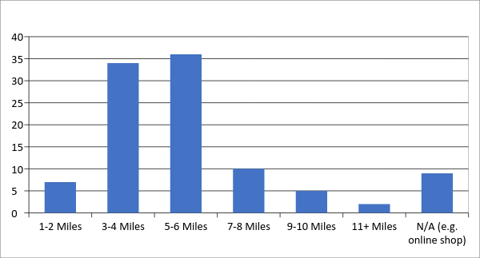

Competitors

We will offer a unique one-stop destination of shop, cafe and garden.

The Thorpe End Village Shop and Post Office has recently closed and although the neighbouring village of Blofield Heath has a convenience store and Post Office, it is located too far away for the majority of our local community to access on foot and therefore necessitates a 3-mile round trip car journey, as it is not on the local bus route. If people have to drive, they may as well drive that little bit further to one of the bigger supermarkets for the everyday essentials that they have run out of or forgotten to buy as part of their weekly shop.

There are tea shops and cafés at Thorpe End, Salhouse and Brundall which are all outside our catchment area.

The Brick Kilns Public House and Restaurant is within walking distance for many residents in Little Plumstead. As complementary businesses, we do not consider we will be in competition with them.

7. The Business

Shop and Café

Following our initial share launch, agreed grant funding and securing an interest free loan over 5 years it was necessary to scale back our original plans. The vision and social benefits remain unchanged, we have however reduced the size and structure of the building itself. We estimate that the total cost of building the shop and café, fitting out and stocking it, and starting the initial phase to regenerate the walled garden will cost £263,250. To date we have received a costing from a local company as outlined below and once we have a final agreement with the Parish Council in place plan to proceed with the build programme . We plan to use a local company and to make the building energy efficient and as low cost to run as possible. We also want to create an enjoyable shopping experience with a light and airy internal space. Stocking a range of everyday essentials and supporting local suppliers wherever possible, helping to reduce food miles. Reducing plastic packaging through bulk purchasing and refilling are options. Being community owned means, we have the flexibility to stock items and sell in any way that the community wants to support.

Construction of the shop and café | 145,000
Fixtures and fittings | 17,000
Architect, survey planning and set up costs | 15,000
Arboreal and making garden walls safe | 61,000
Opening stock | 11,000
Working capital | 10,000
Contingency | 4,000
Total | £263,000

We anticipate this being raised from:
Shareholder Equity
Community Share issue 1 |  | 23,250
Grant Providers
Parish Council-Community Infrastructure Levy-contribution | Agreed in principal for wall repairs | 60,000
Rural Leader development Programme | Approved | 100,000
Local Charitable Trusts |  | 5,000
Co-op Foundation | Grant | 10,000
Co-op Foundation | 5 years interest free loan | 50,000
Bright Ideas Grant | Received | 15,000
 | Total | £263,250
Operational Grant Support
Princes Countryside Fund | Help with salaries and post build trading costs. Application made |  | 20,000

It is essential that we have community support with our share issue, as winning grants depends on this. If necessary we will also seek to put into place an overdraft facility or short-term loan to support cash flow as some grants require stages of the work to be completed to be able to draw down the grant.
The Shop and Café will employ a full-time manager and assistant manager plus one part time member of staff. Local volunteers not only fulfil the remaining staff requirements but also form the core of a loyal customer base going forward.

Our trading projections are based on well-documented and proven evidence from other community businesses and our own market research. Looking at other community shops in East Anglia, Rocklands Community Shop has a community of 280 homes and had a turnover £241,000 in 2017. Great Rybrough has a catchment of 270 houses and had a turnover of £169,000 in 2017.

Our Parish has 1000 homes in Great and Little Plumstead and an additional 500 in Thorpe End Green. Other community shops have told us that a reasonable assumption is that 50% of households in a catchment area will spend around £10 per week. Based on this we have conservatively forecast a first-year turnover of £260,000 covering Great and Little Plumstead only (500 households using the shop).

For the café, our projections are based on serving 15 customers per day with a typical transaction price of £3.75 per customer, showing sales in the first year of £20,475.

Of 300 community shops that have been opened in the last 10 years, none have failed and there is strong evidence that community ownership, with its volunteer support and engagement, is a successful business model. We feel that our successful application for a local Post Office will be a big help in increasing general turnover. The business is forecast to run profitably and on a sustainable basis going forward.

We will make a modest profit in each of the first three years.

 | Year 1 | Year 2 | Year 3
Sales (Shop & café) | 280,475 | 308,523 | 331,808
Purchases (Shop & café) | (211,953) | (232,715) | (250,198)
Post office commission | 3,000 | 3,000 | 3,000
Wages & NI | (52,433) | (55,054) | (57,807)
Depreciation | (8,954) | (9,254) | (9,254)
Trading costs | (13,436) | (14,108) | (14,813)
Amortisation of Grants | 5,656 | 5,656 | 5,656
Trading Profit | £2,355 | £6,048 | £8,392

Our 5-year trading projections and cash flow figures are shown in Appendix 2. At the absolute discretion of the MC, any share capital withdrawal would take place from year 4 onwards and would be funded from accumulated reserves. The MC intends to limit withdrawals to no more than 10% of share capital within each financial year.

8. The Share Offer
The community will all be able to become members of the Society and have a vote through purchasing shares, the first share issue raised £23,250. It is envisaged that a second issue of shares will take place during 2019.

Rocklands community shop raised £45,000 from their share offer and a community of 280 homes. Shouldham Village raised £150,000 to buy their pub from 246 homes. The Plumsteads have more than 1,000 homes so it should be possible to raise at least £100,000 from a community share issue.

The Plunkett Foundation and Power to change have supported us in writing a community share offer prospectus that meets the Community Share Standard mark.

In addition, the MC has applied to HMRC and received advance assurance that this share offer meets the requirements of the Seed Enterprise Investment Scheme (SEIS).

Under this scheme, investors may be able to claim the following tax benefits:

- Investors can obtain 50% relief for income tax on the cost of shares, on a maximum annual investment of £100,000
- Loss relief - Should the company go bankrupt, investors may claim loss relief on their investment and can choose to set the loss amount, less any income tax relief already given, against their income.
- 100% inheritance tax relief (provided the investments have been held for at least two years at time of death).

Under the scheme, investors will be able to claim 50% income tax relief on their share purchase. This is regardless of the rate of tax they pay, providing they have paid sufficient tax to cover the amount being reclaimed.

This can include both tax paid in the year in which the investment is made and the preceding year. The business has to trade for four months before a formal application for qualification for the relief can be made by the business. The relevant form will then be provided, enabling you to make the appropriate claim to HMRC for tax relief at that time.

For further details of SEIS tax reliefs, you should read the HMRC guidance and you should take independent tax advice.

Please note that although we have received advance assurance, the amount of tax relief if any, cannot be guaranteed by the Society.

9. Resource Implications
The success of the project will rely on fundraising from national and local grant providers, investment from the Parish Council and HPFT (Broadland Clinic) and our community share offer.

As the success of the venture relies upon sufficient volunteer staff members to provide convenient opening times, engaging and sourcing enthusiastic volunteers is one priority, the other is to retain these vital volunteers. The Plunkett Foundation have a wealth of experience in this area and hold regular events on how to attract and engage volunteers. We are also fortunate in that so many local residents have already offered their services and with the community expanding this is likely to increase further. The more volunteers we can attract, the less hours they need to commit and the more likely we are to retain their services.

Employing a full-time manager, assistant manager and a part time member of staff is a model of operation that has proved successful in other community shops that the committee has visited. Having a paid manager has been proven to enable better use and retention of volunteers. Through training in using the till system, food safety, health and safety and age-related sales, volunteers are more likely to feel valued members of the team and crucial to the vital operation of the business.

Being able to negotiate good terms on the stock is also vital to the success and sustainability of the business. Being a community shop means we will be able to access discounted services only available to community projects. The Co-op has already offered free advice, whenever required, and favourable wholesale terms on produce too. We are also very keen to source local produce to support local businesses and reduce food miles, wherever possible on a sale or return basis.

10. Timescale
Having agreed in principal at the 8th January2018 meeting to lease the walled garden to the Plumstead Community Shop Ltd, the Parish Council expect the legal paperwork required for the transfer of the freehold to be completed by the Spring of 2019. We expect to have a lease in place shortly afterwards. We hope to start the build in Summer 2019, the shop and café could be ready to stock and open for business pre Christmas 2019

11. Risks
Risk | Mitigation
Unforeseen increases in construction costs prior to opening | The building sub-committee has thoroughly investigated the construction costs and adopted a risk averse costing strategy to minimise the dangers of cost overrun.
Inadequate funding, i.e. failure to raise sufficient capital at the outset | The capital requirements have been carefully identified and work on the project will only commence when sufficient capital has been raised.
Dependency on a volunteer workforce | The Shop will have a salaried manager and at least one further paid member of staff. We now have over 50 residents who have said they would volunteer in the shop or café.
Theft or damage & vandalism | This is not considered a high risk, but nevertheless the Shop will take the usual security precautions to minimise risk in these areas.
Our Parish might not be large enough | Our own detailed investigations and the Plunkett Foundation’s comprehensive reports show existing community shops can profitably service communities that are smaller than ours.
There may be too much competition from existing shops in the area | The nearest large supermarket is a 12-mile round trip. The nearest local shop is a 3-mile round trip.
There may not be enough footfall. | The proposed site is ideally located to attract footfall from local residents and within easy walking distance for the majority of the community. It is adjacent to village’s thriving primary school which is due to double its capacity in 2019.
Parking may be a problem at the proposed location | The central locality of the Shop means that many residents will be able walk/bicycle to the shop, plus a small car park 100mts away will provide ample parking to meet trading forecasts.
Recruiting and retaining the Shop manager | We believe our proposed salary, which is higher than many other community shops should enable us to attract a suitable candidate, excited by the opportunity of opening and operating an attractive community centre.
The Shop may not attract enough volunteers | Currently there are over 50 people who have registered their interest in volunteering and we expect this to grow when the construction is nearing completion.
Sales do not meet plans and/or profits are below expectation | - changing the mix of goods and services on offer to those with higher margins and with greater demand  - improving marketing to bring more customers into the shop eg through focus groups to identify problems, surveys, and increased understanding of our customers  - promotional campaigns to bring in new customers and increase spend from existing customers

12. Communication

The process of community engagement commenced in February 2017. In the first few months our campaign focused on consolidating and building community support for the project and membership of the steering group. Questionnaires and flyers were distributed to every household in both villages, as well as local businesses in the Parish. These were subsequently followed up with a public meeting at the local primary school to inform the community and encourage their further support for the project.

A communications sub-committee was formed from the MC and they have established a dedicated Facebook page, Twitter and Instagram accounts as well as a website for the Walled Garden Community Shop and Café.

A growing database of people have registered their details to be kept up to date via our mailing list, providing a contact database for future advertising of special events and promotional offers.

Monthly updates have been provided to the Parish Newsletter as well as updates to the local media as various milestones are reached. Further public meetings will be held as progress continues.

We plan to offer a loyalty scheme to generate regular customer support and repeat business once the shop and café is up and running as well as holding promotions and tastings to keep interest strong. Community events in the Walled Garden will also provide additional trade.

We have a growing stakeholder base which includes Great and Little Plumstead Parish Council, Broadland District Council, Norfolk County Council, Hertfordshire Partnership Foundation Trust, Little Plumstead Church of England Primary School, The Octagon Business Park, Nelsons Journey, Broadland Clinic, Norfolk Pro Help, Norfolk Community Foundation and a local charitable trust.
Our first Annual General Meeting with an open meeting immediately after is scheduled to take place in March 2019.

Appendix 1 – The Management Committee

Adrian Nagle – Chair

Adrian spent his first 20 working years in the commercial world working with major overseas retailers and importers in a multi-million-pound business. For a brief period, he had his own small business; designing, importing and marketing a range of handmade terracotta pottery from Portugal. For the last 20 years he has travelled with his partner, living and working overseas (mostly property and garden maintenance). He has experienced a diverse range of communities in a variety of environments. His last major stop was on the edge of wilderness in Northern British Columbia, Canada. He also lived in a community group in Norfolk for a year. He says he has been drawn to the project because it has community at its heart and has a vision of the walled garden becoming a place of beauty, well-being and community for all, plus good coffee!

Vicki Aiken - Communications and Marketing

Vicki works as an Occupational Therapist at the Little Plumstead Learning Disability hospital and has ten years’ experience in the NHS.
Vicki's work includes assisting her patients to improve their life skills towards living in the community and find meaningful opportunities which improve their quality of life, including college and work. Vicki has considerable experience running social media and marketing for social organisations and organised a successful conference in 2017.

Louise Amond – Friends of the Walled Garden

Louise was born in Little Plumstead and has worked at Little Plumstead Hospital for 28 years supporting patients with a range of disabilities engage in occupation, learning and therapies. Louise fondly remembers The Walled Garden in its former glory as a space for people to work and relax in.
Along with her husband she has extended and renovated their house and garden and enjoys making and up-cycling furniture and other fixtures. Louise is a keen gardener and is probably happiest being outside growing fruit and vegetables for her kitchen table.
She adds “The project combines both my interests: restoration and growing fruit and vegetables, it’s the perfect thing to be involved in”

Ellie Edgar - Secretary

Ellie has lived in the area for over 30 years. She started working at Little Plumstead Hospital at the beginning of 1998, when the formal Resettlement Process of the patients had just begun – one ward had closed. She was secretary to the Site Manager at the time so was very involved in the running of the site. Eventually, her manager was transferred to the new service as Business Manager and Ellie went with him. Norfolk Learning Difficulties Service was set up jointly between Norfolk Social Services and Norfolk Primary Care Trust to look after the residents who had moved into the community. When her manager retired, the post was transferred to Norfolk County Council.
Hertfordshire Partnership Foundation Trust took over the service that remained at Little Plumstead in April 2008, when she returned as PA to the Service Manager.

During the time she has worked in the Little Plumstead area, two local shops have closed, one of which was also the Post Office. The Post Office has also recently closed in Thorpe End. I was very pleased when I heard the Walled Garden here was hopefully going to be developed as a few years ago, when it was still part of the site, it was beautiful.
Ellie was also secretary to the Blofield and Brundall Sea Scout Group when her sons were growing up where she helped with fundraising.

Debbie Tomkins - Treasurer

Debbie has an accountancy background and latterly worked as a Company Secretary for a listed plc. She is passionate about wildlife conservation and is a regular volunteer at a local RSPB reserve, helping to run events and providing reception cover and office assistance. Debbie and her husband moved to Little Plumstead in 2001, loving the rural feel of the village whilst only being a short drive from Norwich. She is delighted to be involved with the project to create a special and unique place in the community that will not only provide a much-needed local service but has the potential to facilitate other opportunities.

James Richards - Project Manager

James is a business and IT management consultant, who having studied business information systems and later a post graduate award on business leadership, now specialises in portfolio and programme management. James has worked in various business sectors including financial services, critical national infrastructure and construction. He says the local community needs this hub and access to essential services and is excited to lend his experience to the project and be part of the team.

Stephen Howard – Construction

Steve has just retired after a long career in and around Construction. He spent the first three years in the Royal Air Force, then the next 30 years firstly working for the Family Construction Company and then managing the company.
Steve’s experience in construction is from extensions and modernisations to new builds and listed buildings. For the last 16 years he worked for the Offender Learning Service firstly at HMP Wayland and latterly HMP Norwich, initially by working in the workshops teaching construction and then to managing the department with 35 Staff and a 2 million pound budget.
His interests include gardening and walking and for 5 years he was the District Commissioner for Scouts at 1st GLP Group. He became involved in this project in order to give something back to the community.

Appendix 2 - Five Year Forecast
Five Year Forecast
 | Year 1 | Year 2 | Year 3 | Year 4 | Year 5
Income
Retail Sales (excluding VAT) | 260000 | 286000 | 307450 | 322823 | 338964
Less
Cost Of Sales (excluding VAT) | 207967 | 228199 | 245314 | 257581 | 270459
Gross Profit (retail sales) | 52033 | 57801 | 62136 | 65242 | 68505
Café Sales (excluding VAT) | 20475 | 22523 | 24358 | 26855 | 29607
Less
Cost Of Sales (excluding VAT) | 3986 | 4516 | 4884 | 5385 | 5936
Gross Profit (café) | 16489 | 18007 | 19474 | 21470 | 23671
GROSS PROFIT (retail sales & café) | 68522 | 75807 | 81610 | 86713 | 92175
Post Office Commission | 3000 | 3000 | 3000 | 3000 | 3000
TOTAL INCOME | 71522 | 78807 | 84610 | 89713 | 95175
Expenditure
Retail Staff Costs | 52433 | 55054 | 57807 | 60697 | 63732
Indirect costs
Bus rates, Council Tax | 536 | 563 | 591 | 620 | 652
Water / Sewerage | 1180 | 1237 | 1299 | 1366 | 1431
Heat/Light/Power | 3000 | 3150 | 3308 | 3473 | 3647
Equipment Lease Payments | 800 | 840 | 882 | 926 | 972
Insurances | 460 | 483 | 507 | 533 | 559
Audit fees | 900 | 945 | 992 | 1042 | 1094
Professional Fees | 400 | 420 | 441 | 463 | 486
Garden maintenance | 1000 | 1050 | 1103 | 1158 | 1216
Building maintenance | 800 | 840 | 882 | 926 | 972
Security Costs, including maintenance & service | 600 | 630 | 662 | 695 | 729
Telephone/internet | 430 | 452 | 474 | 498 | 523
Uniforms | 230 | 242 | 254 | 266 | 280
Advertising and Promotions | 300 | 315 | 331 | 347 | 365
Bank charges | 400 | 420 | 441 | 463 | 486
Cleaning | 100 | 105 | 110 | 116 | 122
Computer costs / website | 1200 | 1260 | 1323 | 1389 | 1459
Postage and Stationery | 300 | 315 | 331 | 347 | 365
Miscellaneous | 400 | 420 | 441 | 463 | 486
Depreciation | 8954 | 9254 | 9254 | 9454 | 9654
Licences | 100 | 105 | 110 | 116 | 122
Subscriptions | 300 | 315 | 331 | 347 | 365
Sub Total | 22390 | 23361 | 24067 | 25008 | 25985
TOTAL EXPENDITURE | 74823 | 78415 | 81874 | 85705 | 89717
Amortisation of Grants Received | (5656) | (5656) | (5656) | (5656) | (5656)
Net Profit before tax | £2355 | £6048 | £8392 | £9664 | £11114

Appendix 3 – Balance Sheet

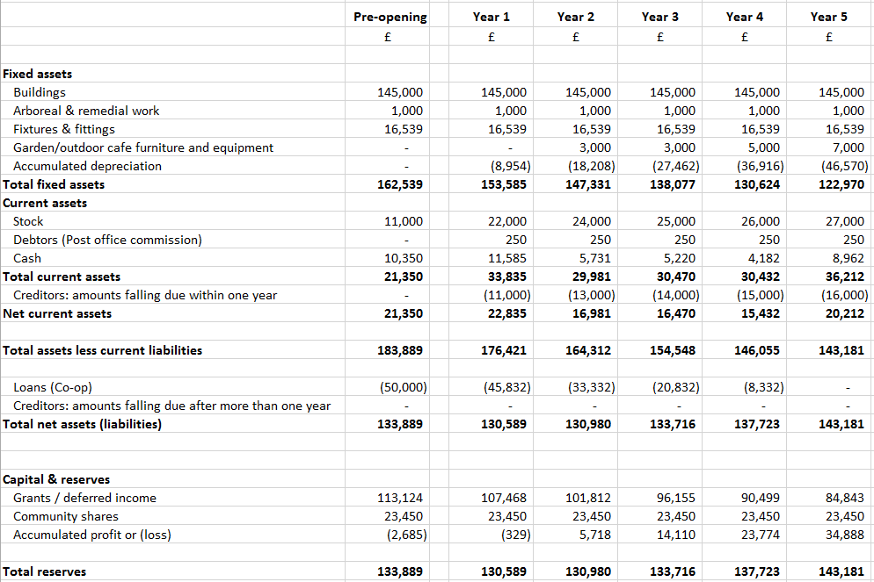

Appendix 4 – Income & Expenditure
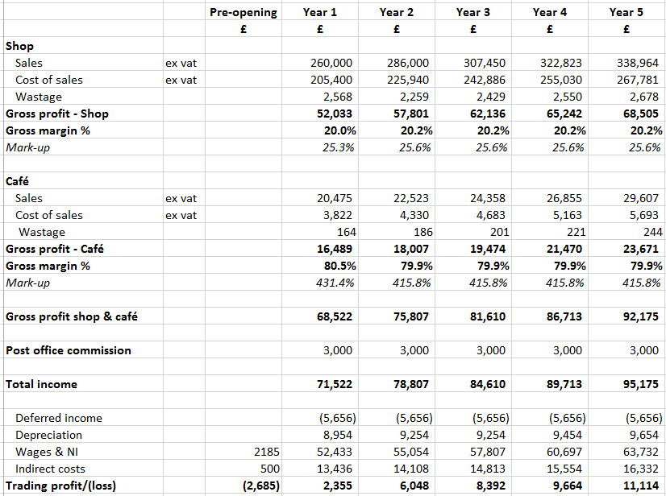

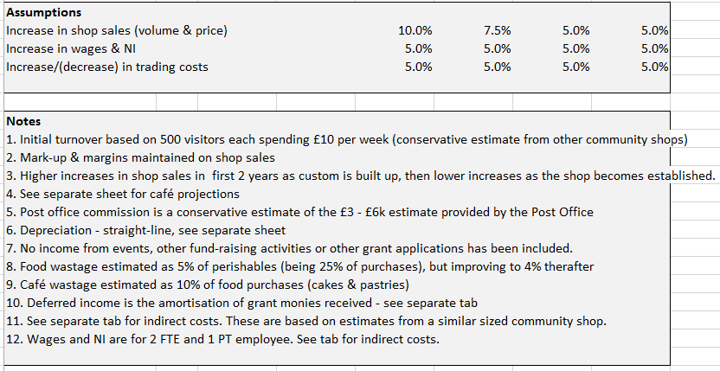

Appendix 5 – Café projections
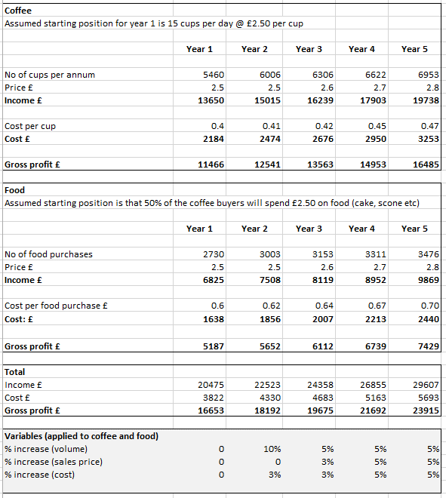

Appendix 6 - Cashflow

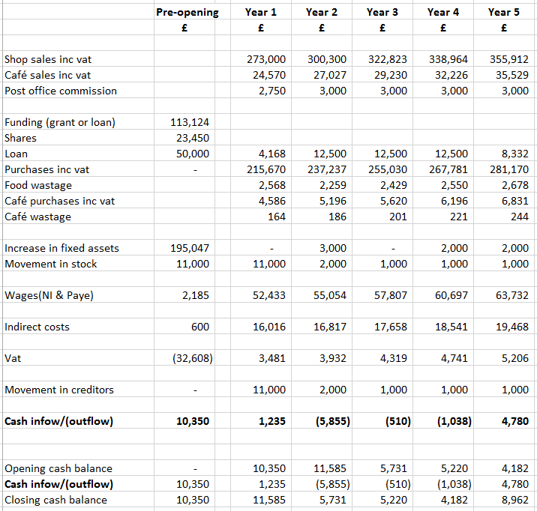

Appendix 7 – Year 1 projections by month

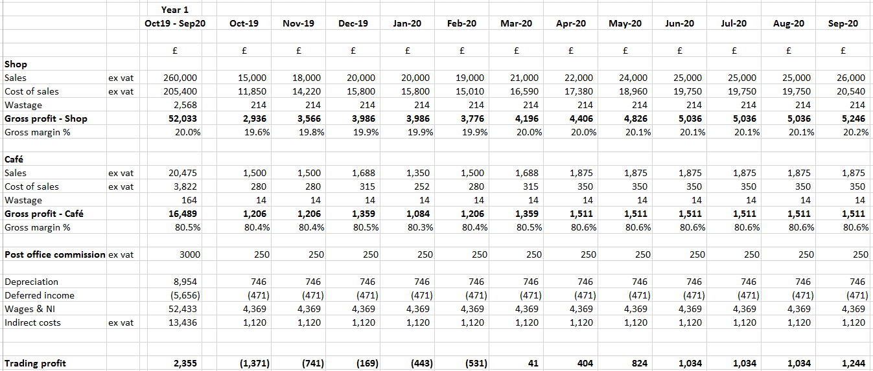

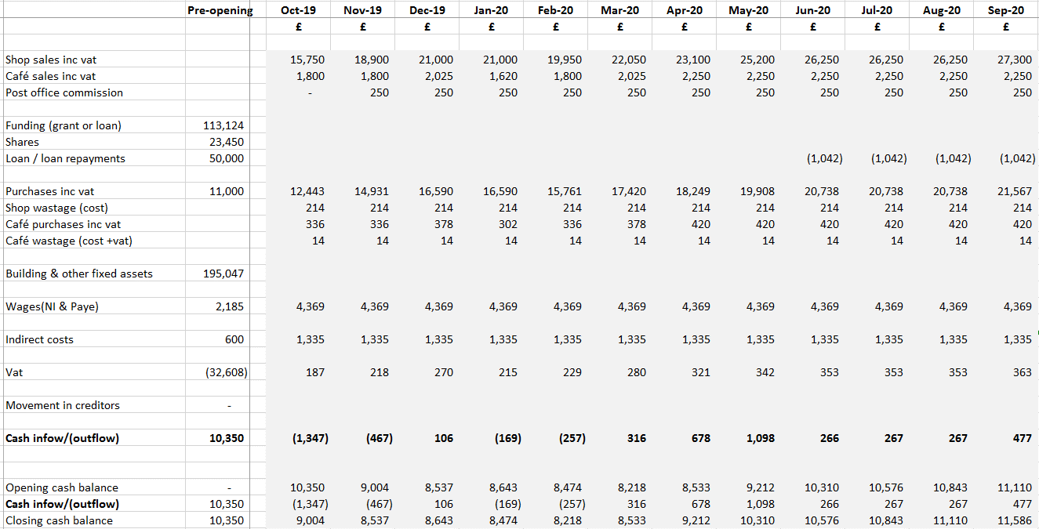

Appendix 8 - Depreciation

